OS Lab #6
Question 1

/*
Write a multithreaded program that generates the Fibonacci series.
The program should work as follows: The user will enter on the command
line the number of Fibonacci numbers that the program is to generate.
The program then will create a separate thread that will generate the
Fibonacci numbers, placing the sequence in data that is shared by the
threads (an array is probably the most convenient data structure).
When the thread finishes execution, the parent will output the sequence
generated by the child thread. Because the parent thread cannot begin
outputting the Fibonacci sequence until the child thread finishes,
this will require having the parent thread wait for the child thread to finish.
*/

#include<stdio.h>
#include<stdlib.h>
#include<pthread.h>

void* generate_fibonacci(void* param)
{
// initializing array and values
int* arr = (int*)param;
int n = arr[0];
arr[1] = 0;
arr[2] = 1;

// creating fibonacci series in array
for(int i = 3;i <= n;i++)
{
arr[i] = arr[i-1] + arr[i-2];
}
return NULL;
}

int main(int argc, char const *argv[])
{
// getting the number of fibbonaci number we are to print
int n;
printf("Enter no of Fibonacci numbers : \n");
scanf("%d",&n);

// dynamically initializing our array
int* arr = (int*)malloc((n+1)*sizeof(int));
arr[0] = n;

// creating thread
pthread_t thread;

// running routine and passing array
pthread_create(&thread,0,&generate_fibonacci,(void*)arr);

// joining child threads to the main thread
pthread_join(thread,0);

// printing out values
for(int i = 1;i <= n;i++)
printf("%d ",arr[i]);
printf("\n");

return 0;
}

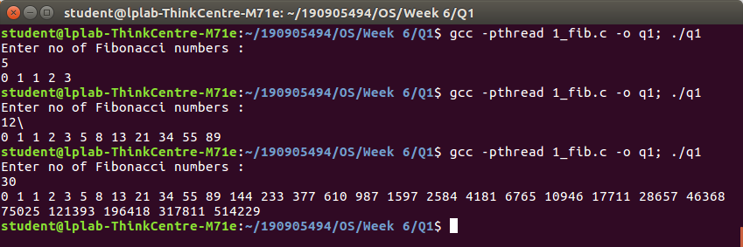

Question 2

/*
Write a multithreaded program that calculates the summation
of non-negative integers in a separate thread and passes the
result to the main thread.
*/

#include<stdio.h>
#include<stdlib.h>
#include<pthread.h>

void* summation(void *param)
{
// initializing array
int* arr = (int*)param;
long sum = 0;
int n = arr[0];

// summing and returning
for(int i = 1;i <= n;i++) {
if(arr[i] > 0)
sum += arr[i];
}

return (void*)sum;
}

int main(int argc, char const *argv[])
{
// initializing and getting the numbers
int n;
printf("Enter the no. of numbers : \n");
scanf("%d",&n);

// dynamically initializing our array
int* arr = (int*)malloc((n+1)*sizeof(int));
arr[0] = n;

// entering values
printf("Enter the numbers : \n");
for(int i= 1;i <= n;i++)
{
scanf("%d",&arr[i]);
}

int answer = 0;

// creating thread
pthread_t thread;

// running routine and passing array
pthread_create(&thread,0,&summation,(void*)arr);

// joining child threads to the main thread
pthread_join(thread,(void**)&answer);

// printing answer
printf("Summation of non-negative numbers = %d\n",answer);

return 0;
}

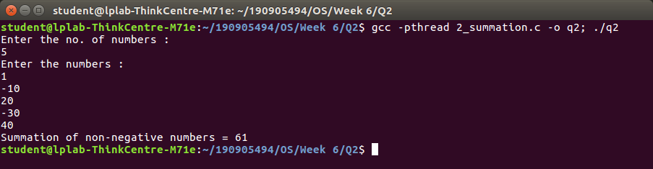

Question 3

/*
Write a multithreaded program for generating prime numbers from
a given starting number to the given ending number.
*/

#include<stdio.h>
#include <stdlib.h>
#include<pthread.h>

#define N 30
#define MAX_THREADS 4

int prime_arr[N]={0};

void *printprime(void *ptr)
{
// initializing values
int j,flag;
int i=(int)(long long int)ptr;

// finding prime numbers
while(i<N)
{
printf("Thread id[%d] checking [%d]\n",pthread_self(),i);
flag=0;
for(j=2;j<=i/2;j++)
{
if(i%j==0)
{
flag=1;
break;
}
}

if(flag==0 && (i>1))
{
prime_arr[i]=1;
}
i+=MAX_THREADS;
}
}

int main()
{
// initializing values and threads
pthread_t tid[MAX_THREADS]={0};
long count=0;

// enterning min and max values
printf("Enter starting and ending\n");
int st,en;
scanf("%d %d",&st,&en);

for(count=0;count<MAX_THREADS;count++)
{
printf("\r\n CREATING THREADS %d",count);
// running routine and passing array
pthread_create(&tid[count],NULL,printprime,(void*)count);
}
printf("\n");

for(count=0;count<MAX_THREADS;count++)
{
// joining child threads to the main thread
pthread_join(tid[count],NULL);
}

int c=0;

// printing solution
for(count=st;count<en;count++)
if(prime_arr[count]==1)
printf("%ld ",count);
printf("\n");

return 0;
}

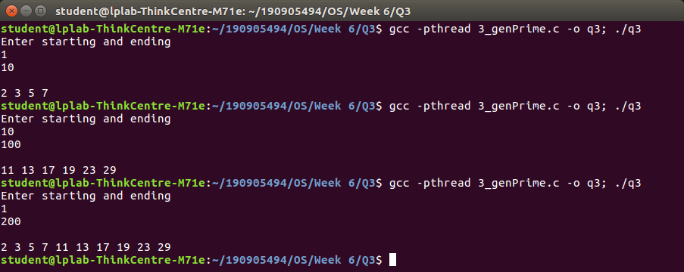

Question 4

/*
Write a multithreaded program that performs the sum of even numbers and odd numbers in an
input array. Create a separate thread to perform the sum of even numbers and odd numbers.
The parent thread has to wait until both the threads are done.
*/

#include <stdlib.h>
#include <stdio.h>
#include <pthread.h>
#include <string.h>

void *even(void *brr)
{
// initializing array and values
int *arr = (int *)brr;
int size = arr[0];
long sum = 0;

// finding even sum
for (int i = 1; i <= size; i++)
if (arr[i] % 2 == 0)
sum += arr[i];
return (void *)sum;
}
void *odd(void *brr)
{
// initializing array and values
int *arr = (int *)brr;
int size = arr[0];
long sum = 0;

// finding odd sum
for (int i = 1; i <= size; i++)
if (arr[i] % 2 != 0)
sum += arr[i];
return (void *)sum;
}

int main()
{
// initializing values
int n, evenSum, oddSum;

// getting array information
printf("Enter The Number of Elements of the Array: \n");
scanf("%d", &n);
int arr[n + 1];
arr[0] = n;
printf("Enter The Elements in the Array:\n");
for (int i = 1; i <= n; i++)
scanf("%d", &arr[i]);

// creating thread
pthread_t t1, t2;

// running routine and passing array
pthread_create(&t1, 0, &even, (void *)arr);
pthread_create(&t2, 0, &odd, (void *)arr);

// joining child threads to the main thread
pthread_join(t1, (void *)&evenSum);
pthread_join(t2, (void *)&oddSum);

// showing outputs
printf("The Sum of Even Numbers of the Array is: %d\n", (int)evenSum);
printf("The Sum of Odd Numbers of the Array is: %d\n", (int)oddSum);
}
